A.M.J. SPOT WELDER V2

The 2-pulse spot welder of the Erdőkertesi Microcontroller Club. www.2113.hu

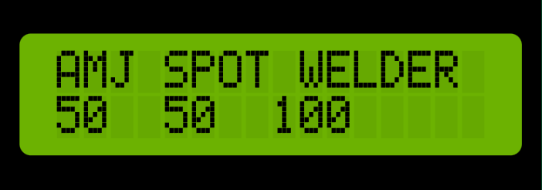
Settings:
1: Select preheating time
2: Selecting the time between preheating and spot welding
3: Selecting spot welding time
4: Adding value 1 ms (+1)
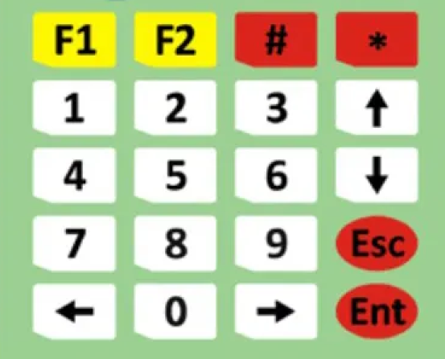
7: Decrease value 1 ms (-1)
5: Adding value 5 ms (+5)
8: Decrease value 5 ms (-5)
6: Adding value 10 ms (+10)
9: Decrease value 10 ms (-10)
0: Reset values to zero(0,0,0)
*: Spot welding test
#: Turning on the fan
F1: Pre-programmed mode(70,50,120)
F2: Pre-programmed mode(90,50,140)
Esc:
Ent:

© 2024 Erdőkertesi Mikrokontroller Klub

